CURRICULUM VITAE
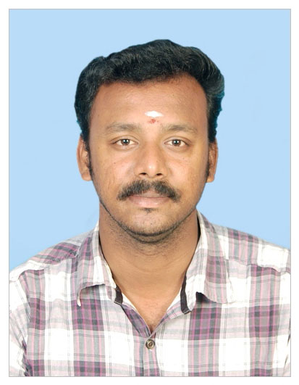
31, NAGORE MAIN ROAD,
AMMALCHATHIRAM,
NERAVE POST
KARAIKAL – 609604
PUDUCHERRY (U.T.)
Cell: 95149-26001, 79048-55027
E-mail: malarskumaran@gmail.com

NAME: V. SELVA KUMARAN

CAREER OBJECTIVE:
To be innovative in jobs that I do, to reach the goal by effective application of my potential, to develop a good team spirit and to thrive in our challenging society. With my experience and knowledge, I would like to bring a major change in the education system by implementing innovative ideas and ideals. As an intelligent communicator, I would like to interact with lots of people, and work as a self-motivated person for planning organizational procedures and practices.
PERSONAL PROFILE:
A team player and a quick study, able to easily assimilate new technology adapt to change.
EDUCATIONAL QUALIFICATION:
COURSE | INSTITUTION | EXAMINATION AUTHORITY | YEAR OF PASSING | PERCENTAGE OF MARKS
M.Sc.  (MATHS) | Periyar University Salem | Periyar University Salem | Doing | Doing
B. Ed | IGNOU, New Delhi | IGNOU, New Delhi | 2011 | 70
B.Sc.  (MATHS) | Annamalai University  Chidambaram | Annamalai University  Chidambaram | 2009 | 65
D.T.Ed. | Andavar Teacher Training Institute, Nagapattinam. | State Board of  Tamil Nadu | 2006 | 80
H.S.C | Thanthai Periyar Govt. Hr. Sec. School, Karaikal | State Board of  Tamil Nadu | 2004 | 68.9
S.S.L.C | St Mary’s Hr. Sec. School, Karaikal | State Board of  Tamil Nadu | 2002 | 78

PERSONAL DETAILS
Name : V. SELVA KUMARAN
Father’s Name : Vaithilingam. R (Rtd. Physical lecturer)
Mother’s Name : Thamizharasi. V (Home maker)
Date of Birth : 23.08.1986
Age : 32
Gender : Male
Nationality : Indian
Religion : Hindu
Marital status : Married, (Mrs. S. Anushiyaselvakumaran, B.Sc. (Maths), D.T.Ed.)
Language known : Tamil & English
Qualification : M.Sc. (Maths), B.Ed. (Maths), D.T.Ed.
Computer Knowledge : Net Engineer (Hardware & Networking Engeering )
Working Experience : 2 Years worked as a Hardware Service Engineer in
TURBO Computers, Karaikal.
: SRVS National Hr. Sec. School, Karaikal, Handled Higher Secondary Computer Science and Middle level (CBSE) Mathematics from January 2007 to July 2011.
: Chinmaya Vidyalaya (CBSC), Nagapattinam handled high school
level Mathematics from August 2011 to April 2015.
: AKR Academy School (CBSE), Avinashi, Tirupur handled Secondary school level Mathematics from June 2015 to March 2016.
: Amrita Vidyalayam (CBSE), Nagapattinam, handling secondary
level Mathematics from May 2016 to till date. H.O.D. of
Mathematics from classes 6th to 8th. Secondary School level Examination In-charge.
Additional Qualification : Cleared TET (D.t.ed.) – 2013
: Chess Coach
: Rubik Cube Trainer

DECLARATION

I do here by declare that the particulars of information and facts stated herein above are true, correct and complete to the best of my knowledge and belief.
Yours truly
Date: 27.01.2019
Place: Karaikal (V. SELVA KUMARAN)

